**A**

**Project Report on**

**A Hotel’s web-application**

**Submitted to**



**KCES’s**

**INSTITUTE OF MANAGEMENT & RESEARCH,**

**JALGAON.**

**College code: 100010**

**(NAAC Accredited)**

**CA-104(B): WEB PROGRAMMING**

**Submitted by**

1) Name: Kapade Lokesh Dagadu.

(Roll No: - 47)

**Miss. Ankita Tiwari Mr. Uday S. Chatur**

Guidance by MCA Co-Ordinator

**Mrs. Tanuja Mahajan Prof. Dr. Shilpa Bendale**

HOD, Academic Dean Director

|  |  |  |
| --- | --- | --- |
| **Sr. No** | **Contents** | **Page No.** |
| 1 | Introduction | 01 |
| 2 | Input Screen  (Coding: HTML, CSS, BOOTSTRAP,JQUERY) | 02 |
| 3 | Output Screen | 38 |
| 4 | About Languages | 42 |

**Candidate Declaration**

This is to certify that this report represent the original work done by **lokesh kapade** during this project submission as partial fulfilment of requirement for system design project of Master of computer application sem-1, of the Institute of Research and Management , Jalgaon.

**INTRODUCTION**

* **Introduction to project :-**

The `Hotel meridean plazza` is a web-application develop using HTML , CSS , JAVASCRIPT, JQUERY,BOOTSTRAP. The objective of this project is to design an dynamic and simplest user friendly web-application that is useful for the various customer.

Hotel meridean plazza is basically used to build an application program which help people to find and enjoy best pleasure of fresh different types of dishes with different categories South Indian, Khandeshi, Punjabi. It is useful in the way that it makes an easier way to search foods online.

By using this website, customers can easily view the different types of delicious dishes of food and Purchase it from Home also customer can books the rooms and private bars for pairty. You can buy various types of fresh dishes and also book the private events with low rate.

**Input code**

**HTML files:-**

1 . Home page (About Us)

**Description of home page :**

Home page is holding the Hotel’s information like The hotel history , hotels chef’s information and The various services provided by the hotel. Having navigation of the whole web-application on the top.

Some coding screens of home page :

1.

<!DOCTYPE html>

<html lang="en">

<head>

    <meta charset="UTF-8">

    <meta http-equiv="X-UA-Compatible" content="IE=edge">

    <meta name="viewport" content="width=device-width, initial-scale=1.0">

    <link rel="stylesheet" href="../node_modules/bootstrap-icons/font/bootstrap-icons.css">

    <link rel="stylesheet" href="../src/index.css">

    <link rel="stylesheet" href="../src/header-footer.css">

    <title>index page</title>

</head>

<body>

        <header>

            <span class="bi bi-house" style="margin-left: 10px;"></span>

            <span class="headings">Hotel meridean plazza</span>

            <span class="costumer_login">

                <span class="login" style="margin-left:50px;">

                    <a href="#" class="bi bi-person-fill"> Login</a>

                </span>

            </span>

        </header>

        <nav class="navbar">

            <ul class="nav_list">

                <li class="list_items"><a href="../public/index.html" class="list_anchor">About us</a> </li>

                <li class="list_items"><a href="../public/home.html" class="list_anchor">Menus</a></li>

                <li class="list_items"><a href="../public/privte-events.html" class="list_anchor">Private Events</a>

                </li>

                <li class="list_items"><a href="#" class="list_anchor">Reservations</a></li>

                <li class="list_items"><a href="#" class="list_anchor">Online order</a></li>

                <span class="login" style="margin-left:50px;">

                    <a href="../public/sign_up.html" class="bi bi-person-fill"> Login</a>

                </span>

            </ul>

        </nav>

        <section>

            <div class="main_image">

                <div class="shade_about">

                    <span class="aboutus_text"><a href="#">About us</a></span>

                </div>

            </div>

        </section>

        <section>

            <div class="about_info">

                <div class="a_infoheading">

                    <p>About</p>

                </div>

                <div class="a_para">

                    <p>

                        Hotel meridean plazza traditional Indian cuisine with a contemporary atmosphere.

                        A Bay Area legacy for nearly 25 years, our menu is prepared fresh daily from ingredients

                        selected with an eye towards sustainability and a focus on local purveyors. A curated collection

                        of

                        contemporary Indian art sets the stage for an experience rooted in tradition and delivered with

                        a fresh approach.

                        An inspired selection of wine,

                        beer and craft cocktails is specifically designed to complement the menu.

                    </p>

                </div>

            </div>

        </section>

        <section>

            <div class="history_section">

                <div class="dish_pic1">

                </div>

                <div class="history_info">

                    <h1 style=" font-size: 45px; margin-top: 30px;">Our History</h1>

                    <p style="padding: 10px; font-size: 20px;"> <br> <br> <br>

                        The first restaurant to introduce “Butter Chicken” over twenty-five years ago, Amber India has

                        become

                        a Bay Area legacy, paving the way for elevated Indian cuisine. Hewing to tradition while

                        catering to contemporary

                        tastes, Amber India remains an enduring favorite that spans generations. </p>

                    <br> <br> <br>

                    <p style="padding: 10px; font-size: 20px;">

                        The first location opened in Mountain View in 1994, earning great acclaim and being named Best

                        Indian

                        Restaurant in the Bay Area by the San Francisco Chronicle within weeks of opening. Amber India

                        went on to be

                        named one of the Top 100 Restaurant in the Bay Area for many years. </p>

                    <br> <br> <br>

                    <p style="padding: 10px; font-size: 20px;">

                        Throughout the years Amber India has remained popular in the local community, becoming a

                        familiar favorite,

                        a chosen caterer for private events, and a frequent location for business meals.

                    </p>

                    <br> <br> <br>

                    </p>

                </div>

            </div>

        </section>

        <section>

            <div class="team_section">

                <div class="team_info">

                    <h1 style=" font-size: 45px; margin-top: 30px;">Our Team</h1>

                    <br><br><br>

                    <p style="padding: 10px; font-size: 20px; text-align: center;">

                        Founder and owner Vijay Bist personally selects the best classically trained up-and-coming chefs

                        in India to lead the restaurants.

                        With extensive knowledge and experience working in India’s best hotels and restaurants, our

                        chefs bring a wealth of experience

                        and knowledge of traditional Indian cuisine married with a modern appreciation towards

                        hospitality and service.

                    </p>

                    <br> <br> <br>

                    <p style="padding: 10px; font-size: 20px; text-align: center;">

                        Pulling from diverse backgrounds, each is able to contribute new ideas and bring new

                        inspiration.

                        Combining Indian culinary techniques and flavors, with local ingredients, each chef is

                        responsible for preparing not

                        only long-standing Amber India favorites but also new seasonal dishes. Many meridean plazza

                        India alums have gone on to head

                        the kitchens at prestigious

                        Indian restaurants throughout the United States.

                    </p>

                    <br><br><br>

                </div>

                <div class="dish_pic2">

                </div>

            </div>

        </section>

    <footer>

        <div class="social_bar">

            <div class="social_items">

                <span style="color: black; font-size: 35px;">

                    <a class="bi bi-facebook" href="#" style="margin-left:10px"></a>

                </span>

                <span style="color: white; font-size: 35px;">

                    <a href="#" class="bi bi-twitter" style="margin-left:10px"></a>

                </span>

                <span style="color: white; font-size: 35px;">

                    <a href="#" class="bi bi-instagram" style="margin-left:10px"></a>

                </span>

            </div>

        </div>

        <div class="copy_rights">

            <div>&#169; copy-rights Meredian plazza </div>

            <div>2022-2023</div>

        </div>

  </footer>

</body>

</html>

2. Menus page :

**Description about menus :**

Menu page holding the varieties of the menus with their rates, and test information of dishes that customer wish to order.

Some coding screens of the meus page:

<!DOCTYPE html>

<html lang="en">

<head>

    <meta charset="UTF-8">

    <meta http-equiv="X-UA-Compatible" content="IE=edge">

    <meta name="viewport" content="width=device-width, initial-scale=1.0">

    <link rel="stylesheet" href="../node_modules/bootstrap-icons/font/bootstrap-icons.css">

    <link rel="stylesheet" href="../src/home.css">

    <link rel="stylesheet" href="../src/header-footer.css">

    <title>Menues</title>

</head>

<body>

    <header>

        <span class="bi bi-house heaadings" style="margin-left: 10px;"></span>

        <span class="headings">Hotel meridean plazza</span>

        <span class="costumer_login">

            <span class="login" style="margin-left:50px;">

                <a href="" class="bi bi-person-fill " data-bs-target="#view" data-bs-toggle="modal"> Login</a>

            </span>

        </span>

    </header>

    <nav class="navbar">

        <ul class="nav_list">

            <li class="list_items"><a href="../public/index.html" class="list_anchor">About us</a></li>

            <li class="list_items"><a href="../public/home.html" class="list_anchor">Menus</a></li>

            <li class="list_items"><a href="../public/privte-events.html" class="list_anchor">Private Events</a></li>

            <li class="list_items"><a href="#" class="list_anchor">Reservations</a></li>

            <li class="list_items"><a href="#" class="list_anchor">Online order</a></li>

            <span>

                <a href="#" class="bi bi-justify toggle"></a>

            </span>

        </ul>

    </nav>

    <section style="height: 600px; padding:20px;">

        <div class="main_menu">

            <div class="dish_image1">

                <div class="card_header">

                 <img src="../public/assets/dish_pic1.jpg" alt="Manchurian" height="300px" width="100%">

                </div>

                <div class="card_body">

                    <h2 style="margin-top:20px; margin-left: 250px;">Manchurian</h2>

                </div>

                <div class="card_footer">

                    <p>

                        The sauce has a mix of eclectic flavors and tastes like sweet, savory, spicy,

                        sour and umami. <br>

                        The recipe is also vegan. Manchurian in the Indian lingo is a term for

                        fried veggies or fried meat <br>

                        (fish or prawns or chicken) in this spicy-umami sauce !!

                    </p>

                    <h3 style="margin:5px; margin-left: 250px;">Rate : &#8377; 200/-</h3>

                </div>

            </div>

            <div class="dish_image2">

                     <div class="card_header">

                          <img src="../public/assets/dish_pic2.png" alt="shevbhaji" height="300px" width="100%">

                </div>

                <div class="card_body">

                    <h2 style="margin-top:20px; margin-left: 250px;">shevbhaji</h2>

                </div>

                <div class="card_footer">

                    <p>

                        Khandeshi shev bhaji is as the name suggests khandesh special recipe.

                        <br> <br>

                         Red thick shev that s specially made for this bhaji is added to spicy and pungent curry.

                         <br>

                        It is served with bhakari. You can try this recipe !!

                        <br> <br>

                    </p>

                    <h3 style="margin:5px; margin-left: 250px;">Rate : &#8377; 170/-</h3>

                </div>

            </div>

        </div>

    </section>

     <section style="height: 600px; padding:20px;">

        <div class="main_menu">

        <div class="dish_image3">

            <div class="card_header">

                 <img src="../public/assets/dish_pic3.jpg" alt="pavbhaji" height="300px" width="100%">

       </div>

       <div class="card_body">

           <h2 style="margin-top:20px; margin-left: 250px;">pavbhaji</h2>

       </div>

       <div class="card_footer">

           <p>

            Pav bhaji is a spiced mixture of mashed vegetables in a thick gravy served with bread.

            <br>

            Vegetables in the curry may commonly include potatoes, onions, carrots, chillies, peas,

            bell peppers and tomatoes.

            <br>

            Street sellers usually cook the curry on a flat griddle (tava) and serve the dish hot !!

           </p>

           <h3 style="margin:5px; margin-left: 250px;">Rate : &#8377; 170/-</h3>

       </div>

   </div>

   <div class="dish_image4">

    <div class="card_header">

         <img src="../public/assets/dish_pic4.jpg" alt="idali" height="300px" width="100%">

</div>

<div class="card_body">

   <h2 style="margin-top:20px; margin-left: 250px;">Idali Smabar</h2>

</div>

<div class="card_footer">

   <p>

    Idli sambar is a popular South Indian breakfast combination where fluffy soft idli (savory steamed cake) <br>

    is served with hot sambar (vegetable lentil stew).

     It makes a delicious, healthy, comforting, and protein-packed meal !!

   </p>

   <h3 style="margin:5px; margin-left: 250px;">Rate : &#8377; 100/-</h3>

</div>

</div>

     </section>

     <section style="height: 600px; padding:20px;">

        <div class="main_menu">

            <div class="dish_image1">

                <div class="card_header">

                          <img src="../public/assets/dish_pic5.jpg" alt="Kaju-panir" height="300px" width="100%">

                </div>

                <div class="card_body">

                    <h2 style="margin-top:20px; margin-left: 250px;">Kaju Paneer</h2>

                </div>

                <div class="card_footer">

                    <p>

                        Kaju curry/ kaju paneer curry is a delicious curry in which cashew nuts and panner is main

                        ingredients of the dish.

                        Use of cashew in the form of puree gives a eich and cremy taste to the dish !!

                    </p>

                    <h3 style="margin:5px; margin-left: 250px;">Rate : &#8377; 260/-</h3>

                </div>

            </div>

            <div class="dish_image2">

                     <div class="card_header">

                          <img src="../public/assets/dish_pic6.jpg" alt="Dal makkhani" height="300px" width="100%">

                </div>

                <div class="card_body">

                    <h2 style="margin-top:20px; margin-left: 250px;">Dal makkhani</h2>

                </div>

                <div class="card_footer">

                    <p>

                        Dal makkhani is Rich, creamy, buttery, and smoky, Dal Makhani is a very popular North Indian <br>

                         lentil dish made using black lentils, lots of butter, and mild spices.

                         Serve it with naan or jeera rice for an unforgettable meal !!

                    </p>

                    <h3 style="margin:5px; margin-left: 250px;">Rate : &#8377; 240/-</h3>

                </div>

            </div>

        </div>

    </section>

    <footer>

        <div class="social_bar">

            <div class="social_items">

                <span style="color: white; font-size: 35px;">

                    <a class="bi bi-facebook" href="#" style="margin-left:10px"></a>

                </span>

                <span style="color: white; font-size: 35px;">

                    <a href="#" class="bi bi-twitter" style="margin-left:10px"></a>

                </span>

                <span style="color: white; font-size: 35px;">

                    <a href="#" class="bi bi-instagram" style="margin-left:10px"></a>

                </span>

            </div>

        </div>

        <div class="copy_rights">

            <div>&#169; copy-rights Meredian plazza </div>

                                 <div>2022-2023</div>

        </div>

    </footer>

</body>

3. private services page :

**Description of page :**

private page holding the various private services provided by the hotel to the customer like private rooms , private bars at various location of the country .

some coding screens of private services page :

<!DOCTYPE html>

<html lang="en">

<head>

    <meta charset="UTF-8">

    <meta http-equiv="X-UA-Compatible" content="IE=edge">

    <meta name="viewport" content="width=device-width, initial-scale=1.0">

    <link rel="stylesheet" href="../node_modules/bootstrap-icons/font/bootstrap-icons.css">

    <link rel="stylesheet" href="../src/home.css">

    <link rel="stylesheet" href="../src/header-footer.css">

    <link rel="stylesheet" href="../src/private.css">

    <title>Menues</title>

</head>

<body>

    <header>

        <span class="bi bi-house heaadings" style="margin-left: 10px;"></span>

        <span class="headings">Hotel meridean plazza</span>

        <span class="costumer_login">

            <span class="login" style="margin-left:50px;">

                <a href="#" class="bi bi-person-fill "> Login</a>

            </span>

        </span>

    </header>

    <nav class="navbar">

        <ul class="nav_list">

            <li class="list_items"><a href="../public/index.html" class="list_anchor">About us</a></li>

            <li class="list_items"><a href="../public/home.html" class="list_anchor">Menus</a></li>

            <li class="list_items"><a href="../public/privte-events.html" class="list_anchor">Private Events</a></li>

            <li class="list_items"><a href="#" class="list_anchor">Reservations</a></li>

            <li class="list_items"><a href="#" class="list_anchor">Online order</a></li>

            <span>

                <a href="#" class="bi bi-justify toggle"></a>

            </span>

        </ul>

    </nav>

    <section style="height: 450px; display: flex; align-items:center; justify-content: center;">

        <div class="Events_info">

            <div class="Events_text">

                <br> <br> <br>

                meridean plazza offers one-of-a-kind services that specialize in custom-designed events and customized

                menus.

                Our catering team has 20 years of impeccable record and experience delivering with consistency and

                reliability. Our successful presence in the hospitality world for the last two decades is because we

                confidently continue to strive and win your heart.

                <br> <br> <br>

                meridean plazza very own private rooms and banquet facilities can be used for a wide array of events

                from casual family dinners to formal wedding receptions or corporate meetings and gatherings and we have

                relationships with many of the event venues in the area. Our event management team can help you

                customize your event based on your location,

                needs and preferences and we will work with you and your event planners to ensure a smooth event.

            </div>

        </div>

    </section>

    <section style="height: 650px;">

        <div class="main_room" style="display: flex;">

            <div class="room_contruction">

                <div class="room_header" style="padding: 10px;">

                    <img class="room_pic" src="../public/assets/private_room2.jpg" alt="" height="350px" width="100%">

                </div>

                <div class="room_body">

                    <div> New Delhi </div>

                    <div style="font-size: 19px; padding: 15px; font-family: 'Times New Roman', Times, serif;">

                        <span>Private Rooms</span>

                    </div>

                </div>

                <div class="room_footer">

                    <div class="learn_more"><a href="#">LEARN MORE</a></div>

                </div>

            </div>

            <div class="room_contruction">

                <div class="room_header" style="padding: 10px;">

                    <img class="room_pic" src="../public/assets/private_room3.jpg" alt="" height="350px" width="100%">

                </div>

                <div class="room_body">

                    <div> MUMBAI </div>

                    <div style="font-size: 19px; padding: 15px; font-family: 'Times New Roman', Times, serif;">

                        <span>Private Rooms</span>

                    </div>

                </div>

                <div class="room_footer">

                    <div class="learn_more"><a href="#">LEARN MORE</a></div>

                </div>

            </div>

        </div>

    </section>

    <section style="height: 650px; ">

        <div class="main_room" style="display: flex;">

            <div class="room_contruction">

                <div class="room_header" style="padding: 10px;">

                    <img class="room_pic" src="../public/assets/private_room4.jpg" alt="" height="350px" width="100%">

                </div>

                <div class="room_body">

                    <div>BANGALORE</div>

                    <div style="font-size: 19px; padding: 15px; font-family: 'Times New Roman', Times, serif;">

                        <span>Private Rooms</span>

                    </div>

                </div>

                <div class="room_footer">

                    <div class="learn_more"><a href="#">LEARN MORE</a></div>

                </div>

            </div>

            <div class="room_contruction">

                <div class="room_header" style="padding: 10px;">

                    <img class="room_pic" src="../public/assets/priavte_room5.jpg" alt="" height="350px" width="100%">

                </div>

                <div class="room_body">

                    <div>JAIPUR</div>

                    <div style="font-size: 19px; padding: 15px; font-family: 'Times New Roman', Times, serif;">

                        <span>Private Rooms</span>

                    </div>

                </div>

                <div class="room_footer">

                    <div class="learn_more"><a href="#">LEARN MORE</a></div>

                </div>

            </div>

        </div>

    </section>

    <footer>

        <div class="social_bar">

            <div class="social_items">

                <span style="color: white; font-size: 35px;">

                    <a class="bi bi-facebook" href="#" style="margin-left:10px"></a>

                </span>

                <span style="color: white; font-size: 35px;">

                    <a href="#" class="bi bi-twitter" style="margin-left:10px"></a>

                </span>

                <span style="color: white; font-size: 35px;">

                    <a href="#" class="bi bi-instagram" style="margin-left:10px"></a>

                </span>

            </div>

        </div>

        <div class="copy_rights">

            <div>&#169; copy-rights Meredian plazza </div>

            <div>2022-2023</div>

        </div>

    </footer>

</body>

</html>

4. Customer Login :-

This page is collecting the customer info using the bootstrap from inputs , it also having the models which pop up for the existing users.

Some coding screens of the customer Login :-

<!DOCTYPE html>

<html lang="en">

<head>

    <meta charset="UTF-8">

    <meta http-equiv="X-UA-Compatible" content="IE=edge">

    <meta name="viewport" content="width=device-width, initial-scale=1.0">

    <title>sign up</title>

    <link rel="stylesheet" href="../node_modules/bootstrap/dist/css/bootstrap.css">

    <link rel="stylesheet" href="../node_modules/bootstrap-icons/font/bootstrap-icons.css">

</head>

<body style="height: 680;">

    <div class="container-fluid mt-3">

        <div class="d-flex justify-content-center align-items-center">

            <form action=""  style="width:500px;" class="border border-3  p-3">

                <h2 class="mb-3" style="margin-left:100px; color: rgb(6, 12, 37);">Coutemer Login</h2>

                 <div class="mb-2">

                      <label for="FirstName" class="form-label">Fisrt Name</label>

                      <div>

                          <input type="text" name="FirstName" class="form-control">

                      </div>

                 </div>

                 <div class="mb-2">

                    <label for="LastName" class="form-label">Last Name</label>

                    <div>

                        <input type="text" name="LastName" class="form-control">

                    </div>

               </div>

               <div class="mb-2">

                <label for="mail" class="form-label">Email SignUp</label>

                <div>

                    <input type="text" name="mail" class="form-control">

                </div>

           </div>

                <div class="mt-2">

                   <label for="Phonnumber" class="form-label">Phone Number</label>

                   <div>

                      <input type="text" class="form-control" name="Phoennumber">

                   </div>

                </div>

                <div class="mt-2">

                    <label for="Pin" class="form-label">Pin Code</label>

                    <div>

                        <input type="text" class="form-control" name="Pin">

                    </div>

                </div>

                <div class="mt-2">

                    <button class="btn btn-secondary w-25" data-bs-target="#massage" data-bs-toggle="modal">Login</button>

                    <button class="btn btn-danger w-25">Cancel</button>

               </div>

               <div class="mt-2">

                    <a href="" class="" data-bs-target="#view" data-bs-toggle="modal" style="text-decoration: none;">Already coutemer ?</a>

               </div>

            </form>

        </div>

    </div>

      <div class="modal" id="view">

          <div class="d-felx justify-content-center align-items-center">

               <div class="modal-dialog">

                <div class="modal-content">

                    <div class="modal-header">

                            <h2>Sign In</h2>

                            <button class="btn btn-close" data-bs-dismiss="modal"></button>

                    </div>

                    <div class="modal-body">

                        <form action="">

                            <dl>

                                <dd>

                                    <label for="" class="form-label">First Name</label>

                                </dd>

                                <dt>

                                    <input type="text" class="form-control">

                                </dt>

                                <dd>

                                    <label for="" class="form-label">Last Name</label>

                                </dd>

                                <dt>

                                    <input type="text" class="form-control">

                                </dt>

                                <dd>

                                    <label for="" class="form-label">password</label>

                                </dd>

                                <dt>

                                    <input type="text" class="form-control">

                                </dt>

                            </dl>

                       </form>

                    </div>

                    <div class="modal-footer">

                    </div>

               </div>

             </div>

         </div>

      </div>

    <script src="../node_modules/jquery/dist/jquery.js"></script>

    <script src="../node_modules/bootstrap/dist/js/bootstrap.bundle.js"></script>

</body>

</html>

**CSS files :-**

1. Header-footer style :-

* {

    margin: 0px;

    padding: 0px;

}

header {

    background-color: rgba(16, 14, 19, 0.9);

    color: white;

    font-size: 50px;

    height: 90px;

    line-height: 70px;

}

.headings {

    padding: 10px;

    font-family: sans-serif;

    ;

}

.costumer_login {

    text-decoration: none;

    font-size: 18px;

    margin-left: 500px;

}

span>a {

    text-decoration: none;

    color: white;

    font-family: sans-serif;

}

.navbar {

    background-color: rgba(11, 9, 17, 0.9);

    font-size: 18px;

    font-family: sans-serif;

    border-top: 1px solid white;

    padding: 10px;

    height: 25px;

    position: sticky;

    top: 0px;

    z-index: 1;

}

.list_items {

    margin-left: 40px;

    list-style: none;

    display: inline;

    line-height: 30px;

}

.list_anchor {

    text-decoration: none;

    color: white;

    padding: 10px;

}

 a:hover{

       color: rgb(101, 105, 38);

}

.toggle {

    color: white;

    margin-left: 450px;

}

.social_bar{

    height: 25px;

    background-color: rgba(16, 14, 19, 0.9);

}

.social_items{

    position: relative;

    top: 16px;

    margin-left: 30px;

}

.copy_rights{

    background-color:rgba(16, 14, 19, 0.9);

    color: white;

     text-align: center;

2. index page styles :-

.main_image {

    background-repeat: no-repeat;

    background-size: cover;

    background-image: url(../public/assets/mainpic.jpg);

    height: 300px;

}

.shade_about {

    height: 300px;

    width: 100%;

    background-color: rgba(0, 0, 0, 0.4);

    color: white;

    text-align: center;

    font-family: 'Trebuchet MS', 'Lucida Sans Unicode', 'Lucida Grande', 'Lucida Sans', Arial, sans-serif;

    font-size: 45px;

}

.aboutus_text {

    position: relative;

    top: 145px;

}

.about_info {

    background-color: white;

}

.a_infoheading {

    text-align: center;

    padding: 5px;

    margin-top: 20px;

    font-size: 45px;

    color: slategray;

}

.a_para>p {

    text-align: center;

    font-size: 20px;

    height: 100px;

    margin: 20px;

    padding: 15px;

    font-family: 'Times New Roman', Times, serif;

    color: slategray;

}

.history_section {

    display: flex;

}

.dish_pic1 {

    height: 600px;

    width: 50%;

    background-image: url(../public/assets/pic1.jpg);

    background-repeat: no-repeat;

    background-size: cover;

}

.history_info {

    height: 600px;

    width: 50%;

    text-align: center;

    background-color: rgb(220, 230, 220);

    color: rgba(54, 58, 61, 0.7);

}

.team_section {

    display: flex;

}

.dish_pic2 {

    height: 600px;

    width: 50%;

    background-image: url(../public/assets/chef4.jpg);

    background-repeat: no-repeat;

    background-size: cover;

}

.team_info {

    height: 600px;

    width: 50%;

    text-align: center;

    background-color: rgb(238, 237, 206);

    color: rgba(54, 58, 61, 0.7);

}

3. Menus page styles :-

.card_header{

    height: 300px;

    width: 100%;

    background-repeat: no-repeat;

    background-size: cover;

    box-shadow: 4px 7px 4px rgb(51, 66, 78);

    margin-top: 15px;

}

.card_body{

   padding: 5px;

}

.card_footer{

     padding: 5px;

}

.dish_image1,.dish_image2,.dish_image3,.dish_image4,.dish_image5,.dish_image6{

    margin-right: 20px;

   width: 50%;

}

.main_menu{

     display: flex;

}

4. private events style :-

.Events_info{

    text-align: center;

    font-size: 18px;

    height: 300px;

    padding: 30px;

    width: 1170px;

    box-shadow: 4px 4px 8px slategray;

}

.room_contruction{

    width: 55%;

    padding: 20px;

}

.room_pic{

      box-shadow: 4px 4px 5px slategrey;

}

.room_body{

     text-align: center;

     font-size: 35px;

     font-family: 'Times New Roman', Times, serif;

     padding: 15px;

}

.room_footer{

     text-align: center;

     font-size: 18px;

     font-family: 'Times New Roman', Times, serif;

}

.room_footer a{

      text-decoration: none;

}

.learn_more{

    border: 1px solid black;

    background-color: rgb(14, 17, 20);

    padding:8px;

    width: 180px;

    position: relative;

    left: 190px;

}

.learn_more a{

    color: white;

}

.learn_more:hover{

     background-color: white;

     transition: 1.2s;

}

.learn_more:hover a{

     color: black;

}

**Some output screens of the site**

Home page :

1.

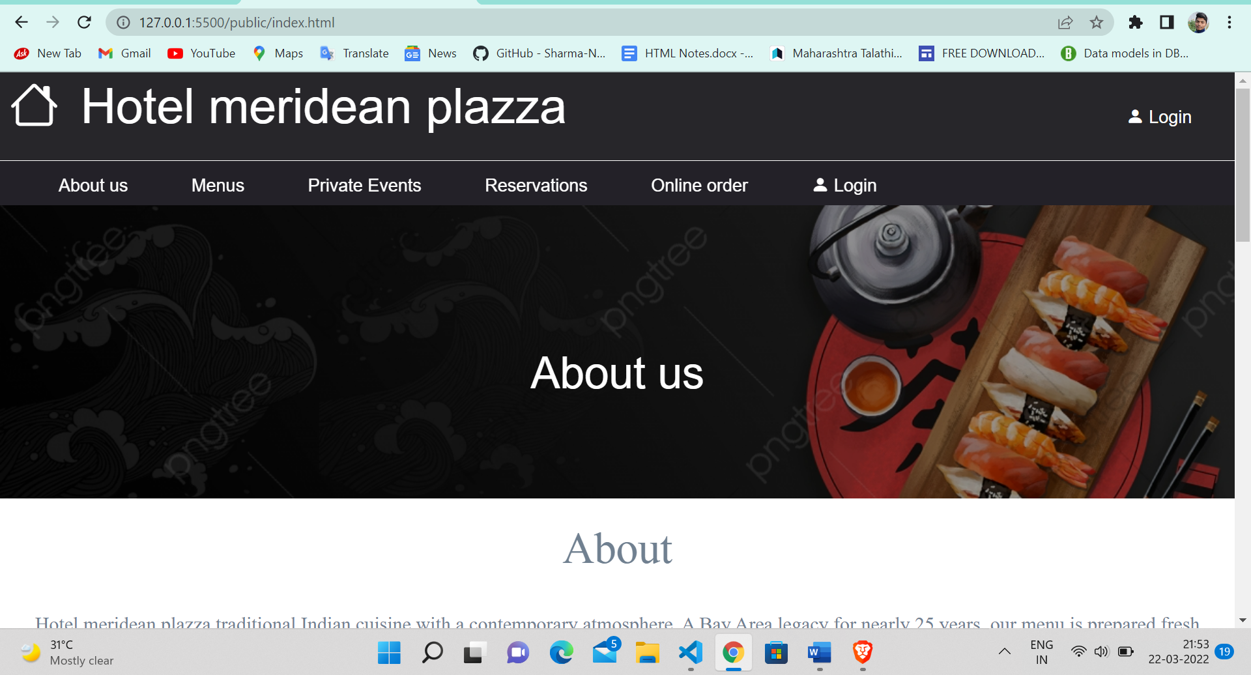

2.

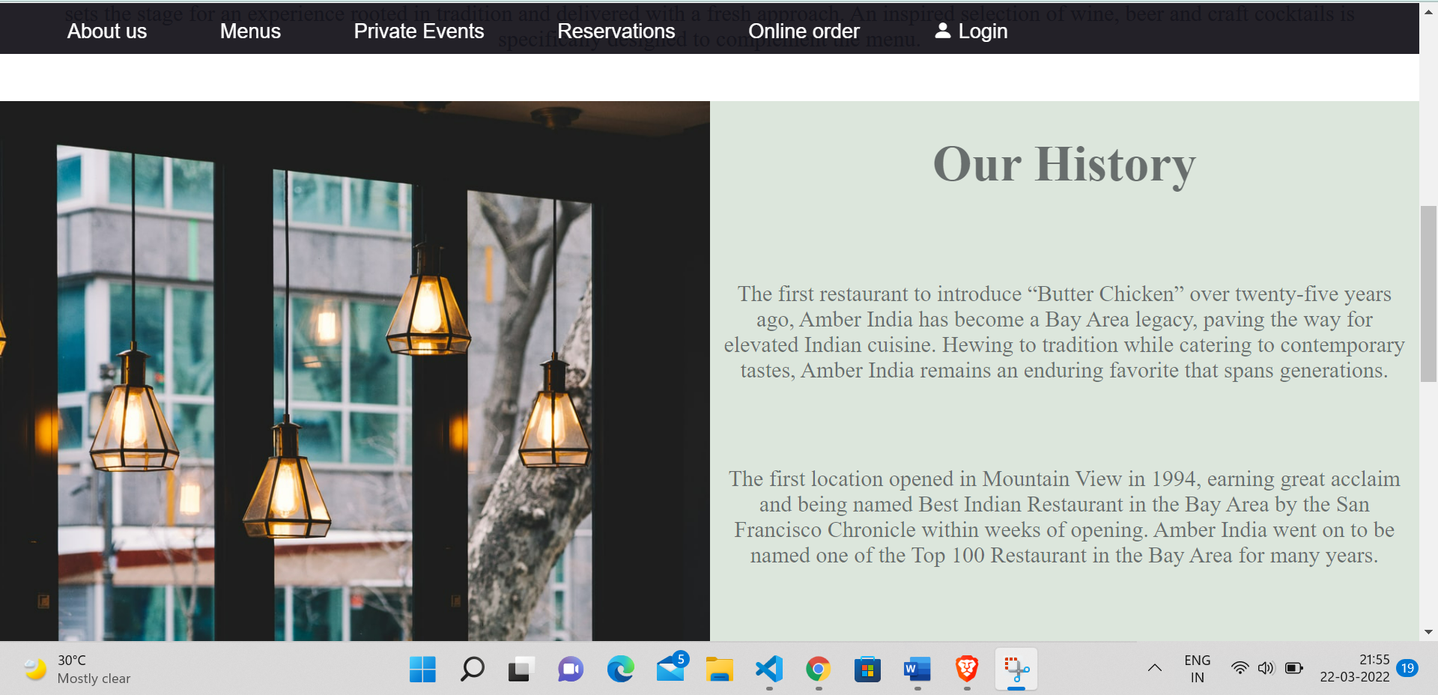

3.

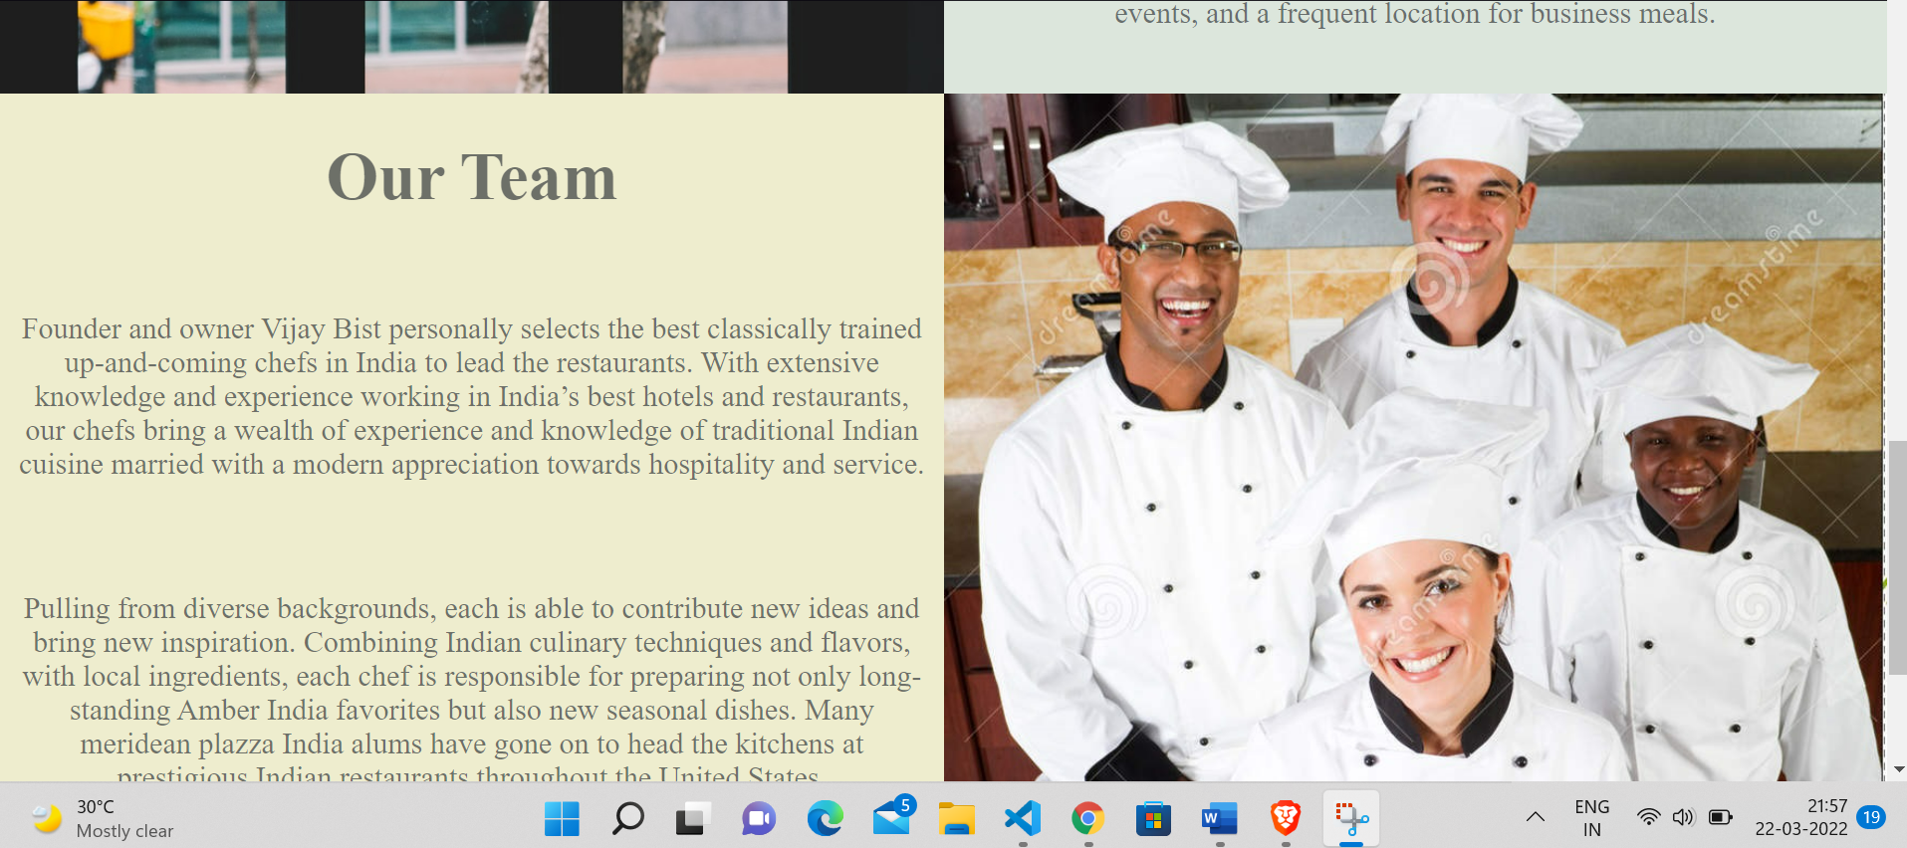

Menus :-

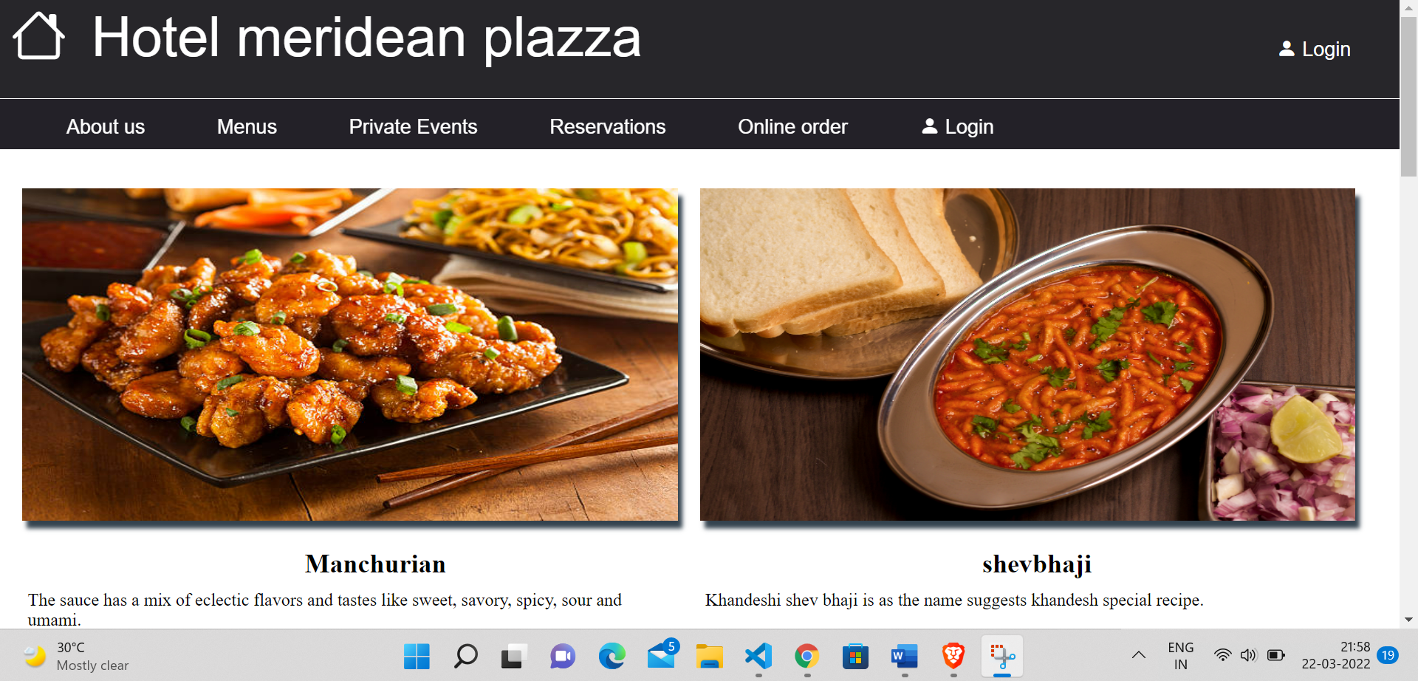

2.

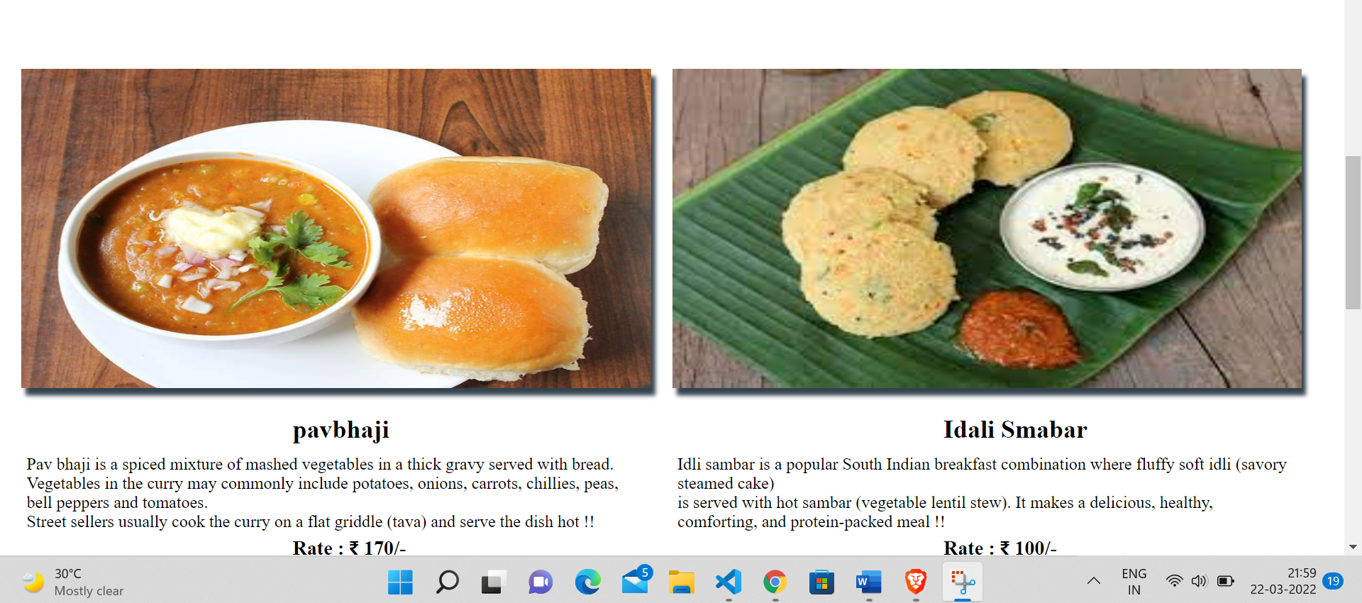

3. private-Events.

1.

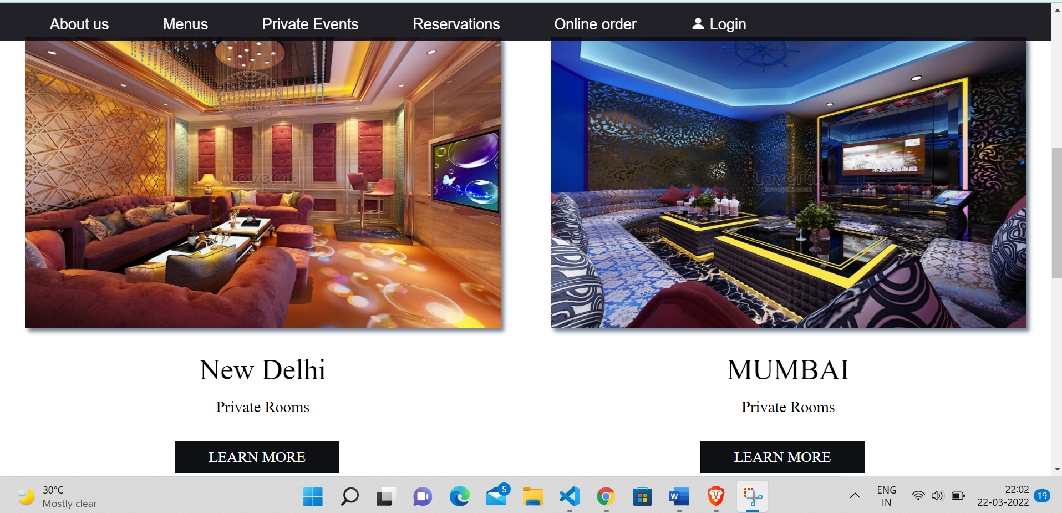

2.

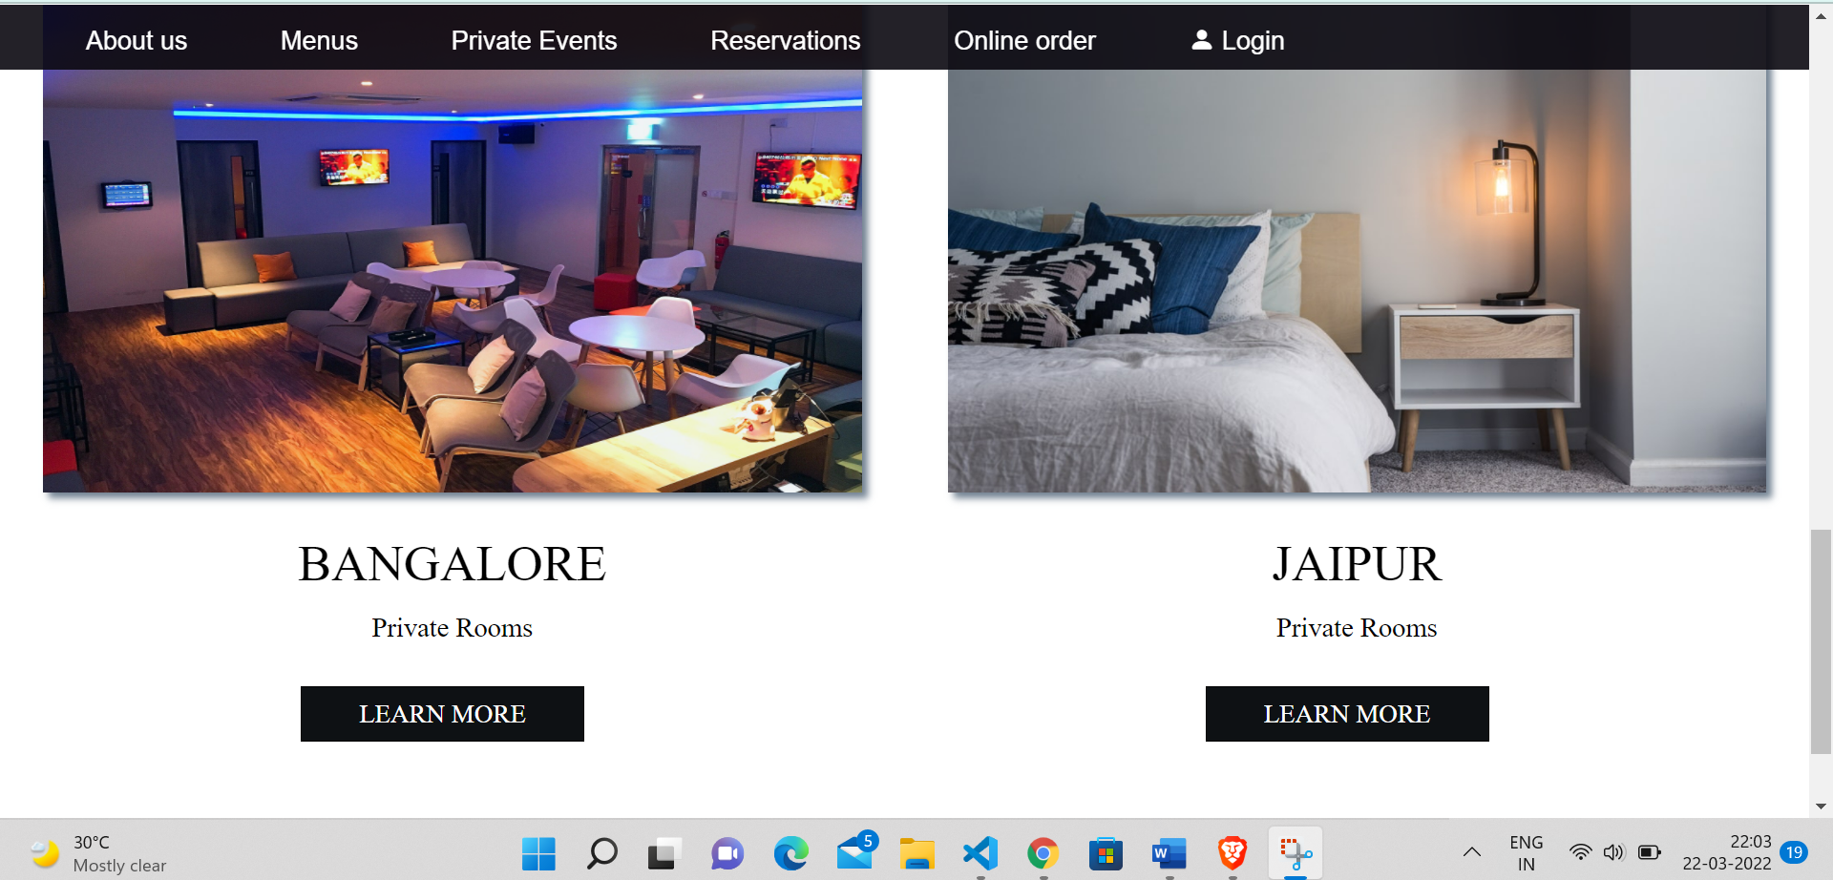

4. customer login:-

1.

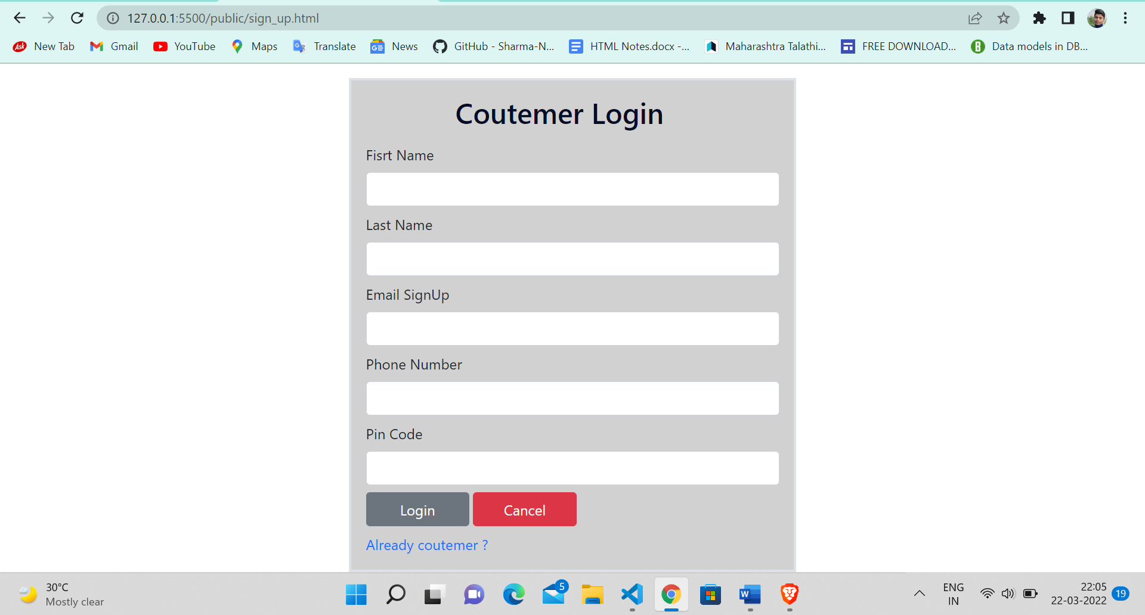

2.

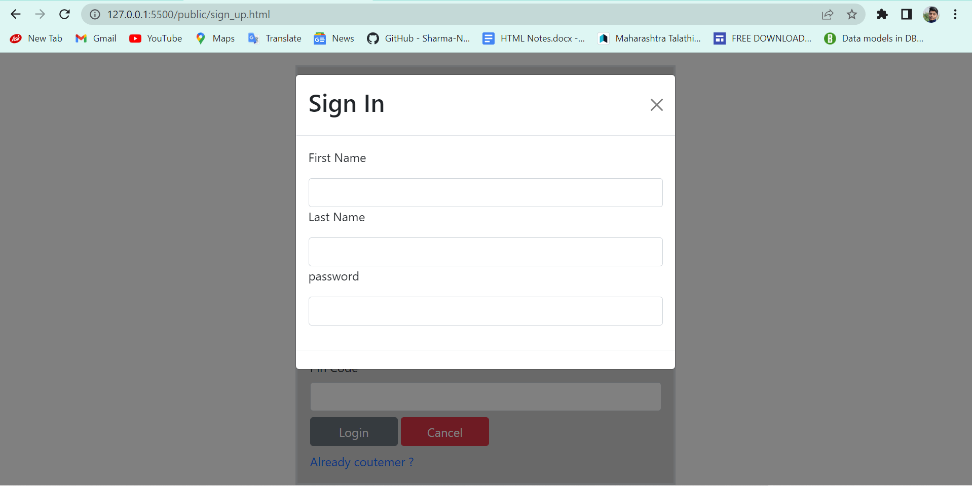

**Languages used : -**

**HTML 5, CSS 3, JavaScript.**

* **HTML 5**

**HTML5** is a markup language used for structuring and presenting content on the world wide web It is the fifth and lastmajor HTML version that is a World Wide Web Consortium (W3C) recommendation. The current specification is known as the HTML Living Standard. It is maintained by a consortium of the major browser vendors (Apple, Google, Mozilla, and Microsoft), the Web Hypertext Application Technology Working Group (WHATWG).

HTML5 was first released in a public-facing form on 22 January 2008,with a major update and "W3C Recommendation" status in October 2014. Its goals were to improve the language with support for the latest multimedia and other new features; to keep the language both easily readable by humans and consistently understood by computers and devices such as web browsers, parsers, etc., without XHTML's rigidity; and to remain backward-compatible with older software. HTML5 is intended to subsume not only HTML 4 but also XHTML 1 and DOM Level 2 HTML.

HTML5 includes detailed processing models to encourage more interoperable implementations; it extends, improves, and rationalizes the markup available for documents and introduces markup and application programming interfaces (APIs) for complex web applications. For the same reasons, HTML5 is also a candidate for cross-platform mobile applications because it includes features designed with low-powered devices in mind.

* **CSS 3**

**Cascading Style Sheets** (**CSS**) is a style sheet language used for describing the presentation of a document written in a markup language such as HTML. CSS is a cornerstone technology of the World Wide Web, alongside HTML and JavaScript.

CSS is designed to enable the separation of presentation and content, including layout, colors, and  fonts. This separation can improve content accessibility, provide more flexibility and control in the specification of presentation characteristics, enable multiple web pages to share formatting by specifying the relevant CSS in a separate .css file which reduces complexity and repetition in the structural content as well as enabling the .css file to be cached to improve the page load speed between the pages that share the file and its formatting.

* **JavaScript**

**JavaScript** (often shortened to **JS**) is a lightweight, interpreted, object-oriented language with first-class functions, and is best known as the scripting language for Web pages, but it's used in many non-browser environments as well. It is a prototype-based, multi-paradigm scripting language that is dynamic, and supports object-oriented, imperative, and functional programming styles.

JavaScript runs on the client side of the web, which can be used to design / program how the web pages behave on the occurrence of an event. JavaScript is an easy to learn and also powerful scripting language, widely used for controlling web page behaviour.

Contrary to popular misconception, **JavaScript is**not**"Interpreted Java"**. In a nutshell, JavaScript is a dynamic scripting language supporting prototype based object construction. The basic syntax is intentionally similar to both Java and C++ to reduce the number of new concepts required to learn the language. Language constructs, such as if statements, for and while loops, and switch and try ... catch blocks function the same as in these languages (or nearly so).

**. Bootstrap : -**

Bootstrap is a free and open source front end development framework for the creation of websites and web apps. The Bootstrap framework is built on HTML, CSS, and JavaScript (JS) to facilitate the development of responsive, mobile-first sites and apps.

Responsive design makes it possible for a web page or app to detect the visitor’s screen size and orientation and automatically adapt the display accordingly; the mobile first approach assumes that smartphones, tablets and task-specific Mobile apps are employees' primary tools for getting work done and addresses the requirements of those technologies in design.

**JQuery :-**

jQuery is a lightweight, "write less, do more", JavaScript library.

The purpose of jQuery is to make it much easier to use JavaScript on your website.

jQuery takes a lot of common tasks that require many lines of JavaScript code to accomplish, and wraps them into methods that you can call with a single line of code.

jQuery also simplifies a lot of the complicated things from JavaScript, like AJAX calls and DOM manipulation.

Conclusion

The Website quality depends upon the phases include in the System Application website should be easy to operate & understand. A high quality website product satisfies the user requirement regarding design specification & maintains flexibility as well